Indications and a map to come at the 25ème Swiss Juggling Convention in 2011.

The 25th Swiss Juggling Convention will take place in the Aimée-Stitelmann School, route de Base, n°24, 1228 Plan-les-Ouates.

If you come by train, stop at the Cornavin station, take the tram 13 or 15 direction "Palettes" stop in "Palettes" (20 minutes, frequency 12 minutes).
Then you can take bus 23 towards ZIPLO or bus 42, direction "Lully" or "P+R Bernex", stop in "Le Rolliet" (duration 5 minutes). The "Aimée-Stitelmann" school is just opposite.
You can also walk from "Pallettes" station a distance of 1 km to the convention.

These informations come from the Web site : http://www.tpg.ch/fr/

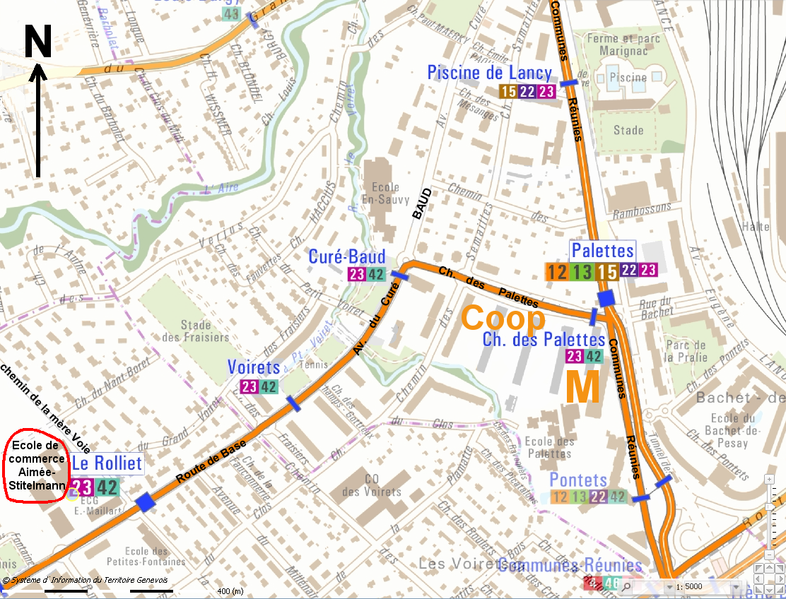
Here is a map to help you.
Map from the Web site : http://etat.geneve.ch/geoportail/plangeneve/ (Look for "Route de Base 24")

